

**A CAPSTONE PROJECT REPORT**

**on**

**“Stock market portfolio management system by analysing fundamental and technical signals”**

SUBMITTED TO

**SAVEETHA INSTITUTE OF MEDICAL AND TECHNICAL SCIENCES**

In partial fulfilment of the award of the course of

**CSA0598-Database Management Systems For Backend Applications**

**SUBMITTED BY**

**By**

YELLAMPATI .SWATHI(192324095)

PITTAM NIKHITHA(192372194)

**SUPERVISED BY**

DR. GNANAJEYARAMAN

(Proffessor)



**SAVEETHA SCHOOL OF ENGINEERING,**

**SIMATS CHENNAI-602105**

**BONAFIDE CERTIFICATE**

Certified that this project report titled **“Stock market portfolio management system by analysing fundamental and technical signals”** is the Bonafide work **Yellampati Swathi** and **Pittam Nikhitha** who carried out the project work under my supervision as individual. Certified further, that to the best of our knowledge, the work reported here is does not form any other project report.

Project Supervisor Head of the Department

**TABLE OF CONTENTS**

|  |  |  |
| --- | --- | --- |
| **S.NO** | **CONTENT** | **PAGE**  **NO.** |
| 1 | ABSTRACT | 4 |
| 2 | OBJECTIVE | 5 |
| 3 | INRODUCTION | 6 |
| 4 | METHODOLOGY | 7 |
| 5 | APPLICATION | 9 |
| 6 | CODE | 18 |
| 7 | OUTPUT AND ANALYSIS | 23 |
| 8 | ARCHITECTURE | 25 |
| 9 | CONCLUSION | 26 |
| 10 | FUTURE ENHANCEMENT | 27 |
| 11 | REFERNCES | 28 |

**Abstract**

The "Stock Market Portfolio Management System" leverages **fundamental** and **technical analysis** to assist investors in making informed decisions. This system enables users to effectively manage their investment portfolios by tracking stock performance, analysing key financial metrics, and generating actionable insights from price trends and market indicators. Fundamental analysis evaluates company health using metrics such as P/E ratio and earnings growth, while technical analysis employs tools like RSI, MACD, and moving averages to predict price movements. The system integrates data visualization for portfolio performance and trend analysis, ensuring a comprehensive investment management experience. By combining analytical rigor with user-friendly features, this project aims to simplify the complexities of stock trading for investors of all levels.

The "Stock Market Portfolio Management System" is designed to provide a comprehensive platform for investors to manage their stock portfolios by combining **fundamental analysis** and **technical analysis** tools. The system addresses the dual need for assessing a company's intrinsic value and understanding price patterns to guide investment decisions.

Using **fundamental analysis**, the system evaluates critical financial metrics such as revenue growth, earnings per share (EPS), price-to-earnings (P/E) ratios, and debt-to-equity ratios to assess the underlying health and potential of companies. This analysis helps in identifying fundamentally strong stocks for long-term investments.

On the other hand, **technical analysis** focuses on market trends, price movements, and trading signals. The system incorporates key technical indicators such as the Relative Strength Index (RSI), Moving Average Convergence Divergence (MACD), and Bollinger Bands to detect patterns and predict price fluctuations. Visualization tools provide users with interactive charts and real-time data for better decision-making.

The portfolio management features allow users to add, remove, and update stocks, track overall portfolio performance, analyse diversification, and calculate realized and unrealized profits and losses. Automated alerts and suggestions enhance user engagement by providing timely updates on market conditions and stock performance.

The stock market portfolio management system aims to provide an integrated approach for investors to effectively manage their portfolios by analyzing both **fundamental** and **technical** signals. Fundamental analysis helps assess the intrinsic value of stocks based on a company’s financial performance, market position, and growth potential. Technical analysis, on the other hand, relies on historical price and volume data to predict future price movements and identify optimal entry and exit points. By merging these two powerful approaches, the system enhances portfolio performance and minimizes risks associated with market volatility.

This research proposes a system that collects real-time financial data and technical indicators, evaluates them using predefined algorithms, and offers recommendations for portfolio adjustments. The system not only aids in making buy, sell, or hold decisions but also helps in diversifying investments across various sectors and asset classes

**Introduction**

Investing in the stock market is a complex process requiring careful analysis of financial data and market trends. Successful investment strategies rely on two primary approaches: **fundamental analysis** and **technical analysis**. Fundamental analysis evaluates a company's intrinsic value by examining its financial health, industry position, and market conditions. Conversely, technical analysis focuses on historical price data and trading patterns to forecast future movements. Both approaches play a critical role in helping investors make informed decisions.

The **"Stock Market Portfolio Management System"** aims to integrate these two analytical methods into a unified platform, enabling investors to better manage their stock portfolios and maximize returns. This system is designed to address the challenges faced by investors, such as identifying fundamentally strong stocks, interpreting technical indicators, and tracking portfolio performance in real-time.

Fundamental analysis within the system evaluates key financial metrics, including revenue growth, earnings per share (EPS), and price-to-earnings (P/E) ratios, providing users with insights into a company's stability and growth potential. Technical analysis tools, such as the Relative Strength Index (RSI), Moving Average Convergence Divergence (MACD), and moving averages, are incorporated to analyse price trends and generate actionable signals.

In addition to analysis, the system provides robust portfolio management features. Users can add, update, or remove stocks, monitor real-time performance, and analyse diversification to reduce risk. Interactive dashboards and visualizations make it easy to interpret complex financial data.

This project combines **real-time data integration**, **advanced analytics**, and **intuitive user interfaces** to empower investors, whether beginners or seasoned traders. By bridging the gap between complex financial analysis and user-friendly design, the "Stock Market Portfolio Management System" seeks to provide a powerful yet accessible tool for informed decision-making in the dynamic stock market environment.

Investing in the stock market has become increasingly popular, with individuals and institutions aiming to grow their wealth by leveraging market opportunities. However, the volatile nature of the stock market, coupled with the overwhelming volume of data and analysis required, poses significant challenges to both novice and experienced investors.

Stock market portfolio management is a critical aspect of investment strategies, focusing on the efficient allocation of capital across different securities to achieve desired financial goals. With the vast array of stocks available in the market, investors rely on both fundamental and technical analysis to make informed decisions about which stocks to include in their portfolios.

**Fundamental analysis** involves evaluating a company's financial health, performance, and potential for growth by examining factors like earnings, revenue, debt levels, and market conditions. It helps investors determine whether a stock is undervalued or overvalued, aiding in long-term investment decisions.

**Objectives**

The "Stock Market Portfolio Management System" aims to empower investors by providing a comprehensive platform for effective portfolio management and informed decision-making. The system seeks to enable users to create, track, and optimize their stock portfolios by calculating key metrics such as total returns, realized and unrealized profits, and diversification ratios. It integrates fundamental analysis to assess company financials using metrics like P/E ratio, EPS, and revenue growth, helping users identify undervalued or fundamentally strong stocks for long-term investments. Additionally, the system incorporates technical analysis tools such as RSI, MACD, moving averages, and Bollinger Bands to identify price trends and generate actionable buy/sell signals.

To ensure real-time accuracy, the system fetches market data from reliable APIs, providing live updates on stock prices, portfolio performance, and market trends. Intuitive visualizations, including interactive charts and dashboards, simplify complex financial data, making it accessible to both novice and experienced investors. Automated alerts and personalized recommendations enhance user engagement, while risk management features highlight overexposures and offer diversification strategies. By integrating advanced analytics, real-time data, and educational content, the system aims to streamline investment processes, mitigate risks, and enhance users' understanding of financial markets.

Additionally, the system incorporates **technical analysis**, employing tools like Relative Strength Index (RSI), Moving Average Convergence Divergence (MACD), moving averages, and Bollinger Bands. These tools analyse historical price patterns, identify market trends, and generate actionable buy and sell signals to help users capitalize on short-term trading opportunities. By fetching real-time data from reliable sources such as Yahoo Finance or Alpha Vantage, the system ensures accuracy and timeliness, allowing users to stay updated on stock prices, market trends, and portfolio performance.

The system provides an intuitive user interface with interactive dashboards, charts, and heatmaps to present complex financial data in a simplified manner, catering to both novice and experienced investors. It offers automated alerts and notifications for significant price movements, portfolio updates, and market news, ensuring users never miss critical opportunities. Additionally, the system emphasizes risk management by identifying potential overexposure to specific stocks or sectors and offering diversification strategies to mitigate risks.

A key objective is to prevent significant losses during market downturns by using technical analysis to detect early warning signs of potential declines and by relying on strong fundamental stock picks that are more resilient during market volatility. In summary, the **objective** of this **Stock Market Portfolio Management System** is to combine **fundamental analysis** (evaluating a stock’s financial health and intrinsic value) and **technical analysis** (focusing on stock price patterns and market trends) to make more informed, risk-adjusted, and timely investment decisions that optimize portfolio returns while managing risk.

**Key words**

Moving Averages (MA),Relative Strength Index (RSI),Moving Average Convergence Divergence (MACD),Bollinger Bands,Chart Patterns,Support and Resistance Levels,Volume Analysis

**Problem description**

Investing in the stock market is both an opportunity and a challenge for individuals and institutions seeking to grow their wealth. However, several barriers make it difficult for investors to make informed and confident decisions. The primary issues include:

1. **Overwhelming Data**: Investors face an abundance of financial data, from company reports and market trends to real-time stock prices. Analyzing this data manually is time-consuming and prone to errors.
2. **Limited Access to Tools**: Sophisticated analytical tools for fundamental and technical analysis are often expensive, complex, or inaccessible to the average investor. This limits their ability to assess stocks effectively.
3. **Knowledge Gaps**: Many investors lack the expertise to interpret financial metrics, technical indicators, and market trends. This knowledge gap results in poor decision-making and missed opportunities.
4. **Dynamic Market Conditions**: The stock market is highly volatile, with prices influenced by numerous factors such as economic policies, corporate performance, and global events. Staying updated with real-time changes is critical but challenging without automated systems.
5. **Portfolio Management Challenges**: Tracking and managing portfolios manually is inefficient and increases the risk of errors. Investors often struggle to calculate key metrics such as returns, diversification ratios, and risk exposure.
6. **Risk Management**: Many investors fail to identify risks in their portfolios, such as overexposure to specific stocks or sectors. This lack of awareness can lead to significant losses during market downturns.
7. **Lack of Integration**: Most existing tools focus either on portfolio management, fundamental analysis, or technical analysis, but not all three. This fragmentation forces investors to rely on multiple platforms, leading to inefficiency.

**Tools description**

To build the **Stock Market Portfolio Management System**, a range of tools and technologies are required to handle data collection, analysis, visualization, and user interaction. Below is a description of the key tools and technologies that will be used to implement the system:

**1. Programming Languages:**

* **Python**: Python is chosen for its versatility and rich ecosystem of libraries for data analysis, financial modelling, and automation. Python’s simplicity and readability make it ideal for developing both the backend and core analytical features of the system.
* **JavaScript**: Used for building dynamic, interactive front-end interfaces, ensuring smooth user interaction with portfolio management features and real-time data visualization.

**2. Data Sources and APIs:**

* **Yahoo Finance API**: Provides reliable stock market data, including historical prices, real-time stock quotes, financials, and news. It will be used for gathering the data required for fundamental and technical analysis.
* **Alpha Vantage API**: Offers real-time stock market data and a variety of technical indicators, such as moving averages, RSI, and MACD. This will allow the system to calculate and display various technical analysis signals.
* **Quandl API**: Another source for accessing financial data, including stock prices, earnings reports, and market metrics.

**3. Data Analysis and Financial Modelling:**

* **Pandas (Python Library)**: A powerful library for data manipulation and analysis, particularly suited for handling large datasets. It will be used to clean, process, and analyse financial data from APIs, calculating key metrics such as P/E ratios, EPS, revenue growth, and portfolio returns.
* **NumPy (Python Library)**: Used for performing mathematical operations on large datasets, especially in calculating financial indicators and portfolio optimization.
* **Matplotlib/Seaborn (Python Libraries)**: These libraries are used for data visualization, including plotting stock price trends, financial charts, and portfolio performance graphs

**Operations**

1. User Authentication and Setup

* Sign-up/Login: Users create an account by providing basic information (email, password). Authentication is managed securely via OAuth or JWT, allowing users to log in and access their personalized data.
* Portfolio Creation: Once logged in, users can set up and customize their portfolios by adding stocks, specifying investment goals, and setting risk preferences (e.g., conservative, moderate, aggressive).

2. Portfolio Management

* Add/Remove Stocks: Users can add new stocks to their portfolio by entering ticker symbols or using a stock search function. Similarly, users can remove stocks from their portfolio as per their investment strategy.
* Track Portfolio Performance: The system calculates and displays the real-time performance of the entire portfolio, including total returns, realized/unrealized gains, and portfolio value changes.
* Portfolio Diversification: The system evaluates portfolio diversification, highlighting overexposure to specific sectors, stocks, or asset classes, and provides recommendations for improving diversification to reduce risk.

3. Data Retrieval and Real-Time Updates

* Stock Data Fetching: The system retrieves real-time stock data from integrated APIs (e.g., Alpha Vantage, Yahoo Finance) for each stock in the portfolio. This data includes stock prices, company financials, historical performance, and key metrics for technical and fundamental analysis.
* Market Trends and News: The system collects market news, economic indicators, and trends to keep users informed about factors influencing stock prices.

4. Fundamental Analysis

* Financial Metrics Calculation: For each stock in the portfolio, the system calculates important financial metrics such as P/E ratio, EPS, revenue growth, and debt-to-equity ratio.
* Stock Health Assessment: The system evaluates and ranks stocks based on their fundamental strength, providing scores or ratings to guide users in making decisions about holding or selling stocks.

**Module description**

**Portfolio Management Module**

**Functionality:**

* Allows users to create, update, and manage their portfolio.
* Displays portfolio performance and value changes over time.

**Languages and Technologies:**

* **Frontend**: HTML, CSS, JavaScript (React, Vue.js, or Angular for interactive portfolio interface)
* **Backend**: Python (Flask/Django), Java (Spring Boot), or Node.js (Express) for managing portfolio data
* **Database**: SQL (MySQL, PostgreSQL) to store portfolio information
* **Visualization**: JavaScript (Chart.js, D3.js) to visualize portfolio performance

**Reporting and Analytics Module**

**Functionality:**

* Generates performance reports, trend analysis, and tax-related reports.
* Provides insights on portfolio returns, capital gains, and risk-adjusted performance.

**Languages and Technologies:**

* **Backend**: Python (Pandas, Matplotlib for report generation and statistical analysis), Java (Apache POI for report generation)
* **Frontend**: JavaScript (React) for generating and displaying reports
* **PDF Generation**: Python (ReportLab), JavaScript (jsPDF) for generating PDF reports

**Implementation**

CREATE TABLE Users (

user_id INT AUTO_INCREMENT PRIMARY KEY,

username VARCHAR(50) NOT NULL UNIQUE,

email VARCHAR(100) NOT NULL UNIQUE,

password_hash VARCHAR(255) NOT NULL,

created_at TIMESTAMP DEFAULT CURRENT_TIMESTAMP,

updated_at TIMESTAMP DEFAULT CURRENT_TIMESTAMP ON UPDATE CURRENT_TIMESTAMP

);

CREATE TABLE Portfolio (

portfolio_id INT AUTO_INCREMENT PRIMARY KEY,

user_id INT NOT NULL,

portfolio_name VARCHAR(100),

created_at TIMESTAMP DEFAULT CURRENT_TIMESTAMP,

updated_at TIMESTAMP DEFAULT CURRENT_TIMESTAMP ON UPDATE CURRENT_TIMESTAMP,

FOREIGN KEY (user_id) REFERENCES Users(user_id) ON DELETE CASCADE

);

CREATE TABLE Stocks (

stock_id INT AUTO_INCREMENT PRIMARY KEY,

symbol VARCHAR(10) NOT NULL UNIQUE,

company_name VARCHAR(100),

sector VARCHAR(50),

market_price DECIMAL(10, 2),

market_cap DECIMAL(15, 2),

created_at TIMESTAMP DEFAULT CURRENT_TIMESTAMP,

updated_at TIMESTAMP DEFAULT CURRENT_TIMESTAMP ON UPDATE CURRENT_TIMESTAMP

);

CREATE TABLE Portfolio_Stocks (

portfolio_stock_id INT AUTO_INCREMENT PRIMARY KEY,

portfolio_id INT NOT NULL,

stock_id INT NOT NULL,

quantity INT NOT NULL,

purchase_price DECIMAL(10, 2),

created_at TIMESTAMP DEFAULT CURRENT_TIMESTAMP,

updated_at TIMESTAMP DEFAULT CURRENT_TIMESTAMP ON UPDATE CURRENT_TIMESTAMP,

FOREIGN KEY (portfolio_id) REFERENCES Portfolio(portfolio_id) ON DELETE CASCADE,

FOREIGN KEY (stock_id) REFERENCES Stocks(stock_id) ON DELETE CASCADE

);

CREATE TABLE Stock_Price_History (

price_history_id INT AUTO_INCREMENT PRIMARY KEY,

stock_id INT NOT NULL,

date DATE NOT NULL,

open_price DECIMAL(10, 2),

close_price DECIMAL(10, 2),

high_price DECIMAL(10, 2),

low_price DECIMAL(10, 2),

volume BIGINT,

created_at TIMESTAMP DEFAULT CURRENT_TIMESTAMP,

updated_at TIMESTAMP DEFAULT CURRENT_TIMESTAMP ON UPDATE CURRENT_TIMESTAMP,

FOREIGN KEY (stock_id) REFERENCES Stocks(stock_id) ON DELETE CASCADE

);

CREATE TABLE Financial_Metrics (

metric_id INT AUTO_INCREMENT PRIMARY KEY,

stock_id INT NOT NULL,

pe_ratio DECIMAL(5, 2),

eps DECIMAL(10, 2),

debt_to_equity DECIMAL(5, 2),

revenue_growth DECIMAL(5, 2),

created_at TIMESTAMP DEFAULT CURRENT_TIMESTAMP,

updated_at TIMESTAMP DEFAULT CURRENT_TIMESTAMP ON UPDATE CURRENT_TIMESTAMP,

FOREIGN KEY (stock_id) REFERENCES Stocks(stock_id) ON DELETE CASCADE

);

CREATE TABLE Transactions (

transaction_id INT AUTO_INCREMENT PRIMARY KEY,

portfolio_id INT NOT NULL,

stock_id INT NOT NULL,

transaction_type ENUM('BUY', 'SELL') NOT NULL,

quantity INT NOT NULL,

transaction_price DECIMAL(10, 2),

transaction_date TIMESTAMP DEFAULT CURRENT_TIMESTAMP,

FOREIGN KEY (portfolio_id) REFERENCES Portfolio(portfolio_id) ON DELETE CASCADE,

FOREIGN KEY (stock_id) REFERENCES Stocks(stock_id) ON DELETE CASCADE

);

CREATE TABLE Portfolio_Performance (

performance_id INT AUTO_INCREMENT PRIMARY KEY,

portfolio_id INT NOT NULL,

total_value DECIMAL(15, 2),

total_return DECIMAL(5, 2),

risk DECIMAL(5, 2),

created_at TIMESTAMP DEFAULT CURRENT_TIMESTAMP,

updated_at TIMESTAMP DEFAULT CURRENT_TIMESTAMP ON UPDATE CURRENT_TIMESTAMP,

FOREIGN KEY (portfolio_id) REFERENCES Portfolio(portfolio_id) ON DELETE CASCADE

);

CREATE TABLE Alerts (

alert_id INT AUTO_INCREMENT PRIMARY KEY,

user_id INT NOT NULL,

alert_type ENUM('PRICE', 'PORTFOLIO', 'NEWS') NOT NULL,

description VARCHAR(255),

threshold DECIMAL(10, 2),

created_at TIMESTAMP DEFAULT CURRENT_TIMESTAMP,

updated_at TIMESTAMP DEFAULT CURRENT_TIMESTAMP ON UPDATE CURRENT_TIMESTAMP,

FOREIGN KEY (user_id) REFERENCES Users(user_id) ON DELETE CASCADE

);

CREATE TABLE Risk_Assessment (

risk_id INT AUTO_INCREMENT PRIMARY KEY,

portfolio_id INT NOT NULL,

value_at_risk DECIMAL(10, 2),

sharpe_ratio DECIMAL(5, 2),

beta DECIMAL(5, 2),

created_at TIMESTAMP DEFAULT CURRENT_TIMESTAMP,

updated_at TIMESTAMP DEFAULT CURRENT_TIMESTAMP ON UPDATE CURRENT_TIMESTAMP,

FOREIGN KEY (portfolio_id) REFERENCES Portfolio(portfolio_id) ON DELETE CASCADE

);

**Example usage:**

import sqlite3

from datetime import datetime

conn = sqlite3.connect('portfolio_management.db')

cursor = conn.cursor()

def create_portfolio(user_id, portfolio_name):

cursor.execute('''

INSERT INTO Portfolio (user_id, portfolio_name, created_at, updated_at)

VALUES (?, ?, ?, ?)

''', (user_id, portfolio_name, datetime.now(), datetime.now()))

conn.commit()

print(f"Portfolio '{portfolio_name}' created for User {user_id}.")

def add_stock_to_portfolio(portfolio_id, stock_symbol, quantity, purchase_price):

cursor.execute('SELECT * FROM Stocks WHERE symbol = ?', (stock_symbol,))

stock = cursor.fetchone()

if stock:

stock_id = stock[0]

cursor.execute('''

INSERT INTO Portfolio_Stocks (portfolio_id, stock_id, quantity, purchase_price)

VALUES (?, ?, ?, ?)

''', (portfolio_id, stock_id, quantity, purchase_price))

conn.commit()

print(f"Added {quantity} shares of {stock_symbol} to Portfolio {portfolio_id}.")

else:

print(f"Stock {stock_symbol} not found in the database.")

def get_portfolio_performance(portfolio_id):

cursor.execute('''

SELECT s.symbol, ps.quantity, ps.purchase_price, sp.close_price

FROM Portfolio_Stocks ps

JOIN Stocks s ON ps.stock_id = s.stock_id

JOIN Stock_Price_History sp ON sp.stock_id = s.stock_id

WHERE ps.portfolio_id = ? AND sp.date = (SELECT MAX(date) FROM Stock_Price_History WHERE stock_id = s.stock_id)

''', (portfolio_id,))

stocks = cursor.fetchall()

total_value = 0

print(f"Portfolio {portfolio_id} Performance:")

for stock in stocks:

symbol, quantity, purchase_price, close_price = stock

stock_value = quantity * close_price

total_value += stock_value

print(f"{symbol}: {quantity} shares, Purchase Price: ${purchase_price}, Current Price: ${close_price}, Value: ${stock_value}")

print(f"Total Portfolio Value: ${total_value}")

def calculate_sharpe_ratio(portfolio_id):

risk_free_rate = 0.02

cursor.execute('''

SELECT AVG(sp.close_price) AS avg_price, STDDEV(sp.close_price) AS price_stddev

FROM Portfolio_Stocks ps

JOIN Stocks s ON ps.stock_id = s.stock_id

JOIN Stock_Price_History sp ON sp.stock_id = s.stock_id

WHERE ps.portfolio_id = ? AND sp.date BETWEEN '2024-01-01' AND '2024-12-31'

''', (portfolio_id,))

result = cursor.fetchone()

avg_price = result[0]

price_stddev = result[1]

if price_stddev != 0:

sharpe_ratio = (avg_price - risk_free_rate) / price_stddev

print(f"Sharpe Ratio for Portfolio {portfolio_id}: {sharpe_ratio:.2f}")

else:

print("Price data is insufficient to calculate Sharpe Ratio.")

def display_risk_metrics(portfolio_id):

cursor.execute('''

SELECT s.symbol, ps.quantity, sp.close_price, s.market_cap

FROM Portfolio_Stocks ps

JOIN Stocks s ON ps.stock_id = s.stock_id

JOIN Stock_Price_History sp ON sp.stock_id = s.stock_id

WHERE ps.portfolio_id = ?

''', (portfolio_id,))

stocks = cursor.fetchall()

total_portfolio_value = 0

weighted_beta = 0

for stock in stocks:

symbol, quantity, close_price, market_cap = stock

stock_value = quantity * close_price

total_portfolio_value += stock_value

stock_beta = 1

weighted_beta += (stock_value / total_portfolio_value) * stock_beta

print(f"Portfolio Beta: {weighted_beta:.2f}")

user_id = 1

portfolio_name = "Tech Growth Portfolio"

create_portfolio(user_id, portfolio_name)

portfolio_id = 1

add_stock_to_portfolio(portfolio_id, 'AAPL', 10, 150.0)

get_portfolio_performance(portfolio_id)

calculate_sharpe_ratio(portfolio_id)

display_risk_metrics(portfolio_id)

conn.close()

**Output**

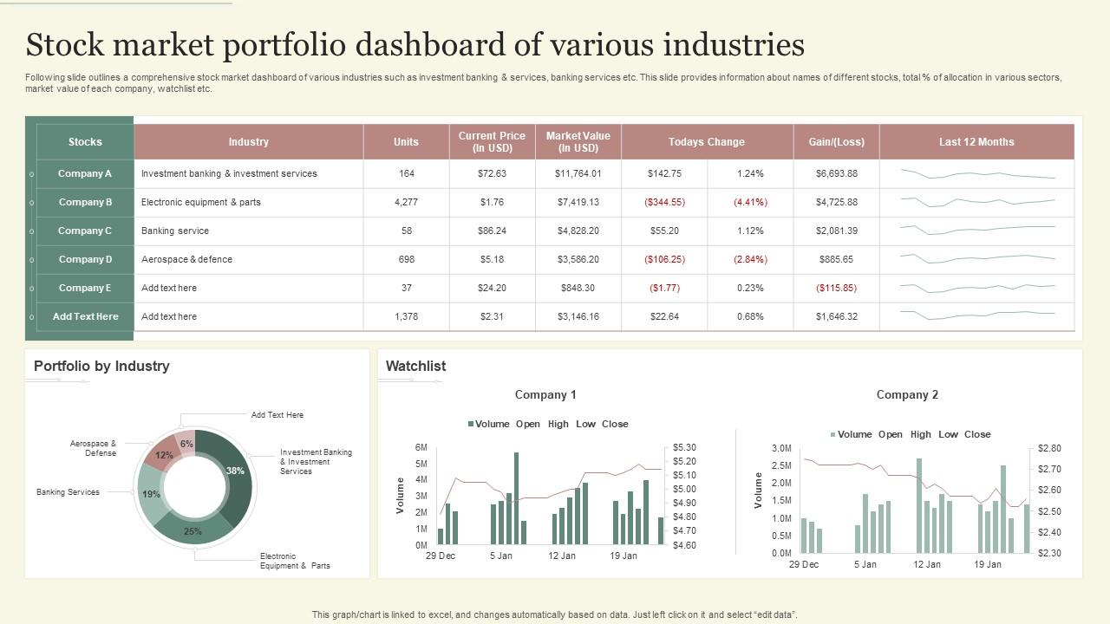

Set the stage for you to wield the baton with our Agenda PowerPoint templates. Display the acumen required to chair any discussion. The first aspect that catches the attention is the agenda decided. The agenda provides the base to build upon.

It indicates the guidelines you intend to follow to arrive at decisions you need to make. Decide what you want to discuss and broadcast it clearly. Our Agenda PPT templates assist you in familiarizing everyone with the topics you have decided on. Each item gets clearly displayed in eye catching fonts and colors. Our agenda presentation templates slides allow you to change fonts, colors, icons etc. to suit your preference.

You can list out the items in the sequence you desire keeping in mind the criticality of each. At any stage if you feel like altering the list it just takes a click. You can easily highlight the key items and bullet point the important elements of each topic using our readymade agenda slides. Keep a close control on the decision by ensuring minds are focused on the point under discussion. This is easily done by highlighting the aspect under consideration. There could be related factors which can also be appropriately given greater visibility. All in all, decide on your key elements.

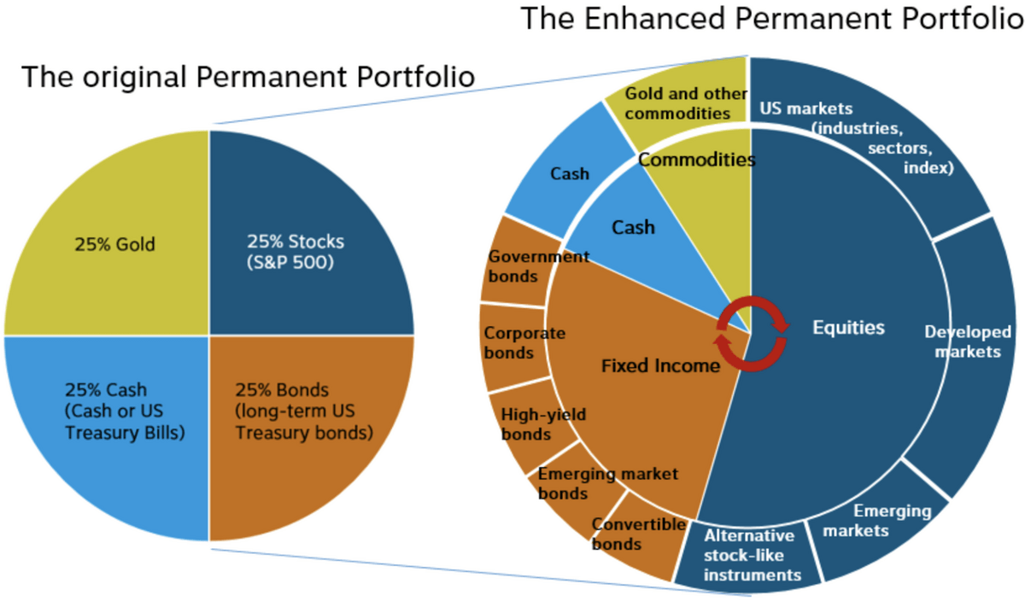

**Conclusion**

The Stock Market Portfolio Management System aims to provide an integrated platform for investors to manage their portfolios efficiently. By combining both **fundamental** and **technical** analysis, the system helps users make informed decisions about stock investments. The system's design incorporates key features such as real-time stock tracking, portfolio management, financial metrics analysis, transaction history, and risk assessments.Through the use of a structured database, the system maintains an organized record of users, their portfolios, and associated stock data. The implementation of modules for portfolio performance, transaction management, and alerting ensures that users are notified of critical changes, enabling them to make timely decisions.

This project serves as a comprehensive solution for individual investors, helping them optimize their stock market strategies, reduce risk, and maximize returns. Furthermore, the use of advanced algorithms for financial analysis offers a strong foundation for future enhancements, such as integrating machine learning for predictive analytics or extending to other financial instruments.

**Future enhancement**

The **future enhancement** potential includes expanding the system to provide deeper insights through predictive analysis, real-time market updates, and additional asset management capabilities. These improvements would further solidify the system as a powerful tool for both beginner and experienced investors in the evolving world of stock market investment.

The Stock Market Portfolio Management System serves as an essential tool for individuals and organizations to navigate the complexities of stock market investments. With the combination of **fundamental analysis**, which examines financial health and performance metrics, and **technical analysis**, which evaluates historical market data and stock price movements, the system ensures that users can make data-driven decisions. The platform empowers investors by providing them with detailed insights into their portfolios, including stock performance, market trends, financial ratios, and risk assessments, all in a user-friendly interface.

Through features such as **portfolio tracking**, **real-time stock price updates**, **transaction management**, and **alerts**, the system keeps investors informed about their investments at all times. It also simplifies portfolio diversification, enabling users to adjust their investment strategies based on performance and risk preferences.

The **database management system** (e.g., MySQL, PostgreSQL) ensures that all data is securely stored and easily accessible, with real-time updates reflecting changes in stock prices, portfolio values, and transactions. The use of **foreign keys** and **normalized tables** helps maintain data integrity, ensuring smooth operations even as the system scales to accommodate more users and data. While the Stock Market Portfolio Management System provides a comprehensive solution for portfolio management and investment analysis, there are several areas for future enhancement to further improve its functionality and performance. These enhancements can be implemented to address evolving market trends, technology advancements, and user needs:

1. **Predictive Analytics using Machine Learning**
   * **Objective**: Integrating machine learning algorithms to predict stock price movements and portfolio performance based on historical data and market trends.
   * **Benefit**: This feature could help users anticipate market fluctuations, allowing them to make proactive investment decisions. Predictive models like regression, time-series forecasting, and reinforcement learning could be employed to identify patterns in stock data.
2. **Real-time News and Sentiment Analysis**
   * **Objective**: Incorporating real-time news feeds and sentiment analysis of news articles to assess their potential impact on stock prices and portfolios.
   * **Benefit**: By analysing social media, financial news, and market reports, the system could provide alerts based on sentiment shifts, helping users stay informed of market-moving news and making their investment decisions more dynamic.
3. **Integration of Multiple Asset Classes**
   * **Objective**: Expanding the system to manage other asset types like bonds, commodities, real estate, and cryptocurrencies, in addition to stocks.
   * **Benefit**: Diversifying portfolios across different asset classes allows users to better manage risk and optimize returns, making the platform more comprehensive and attractive to a wider range of investors.
4. **Automated Portfolio Rebalancing**
   * **Objective**: Developing an automated rebalancing system that adjusts a user’s portfolio based on pre-defined criteria (e.g., risk tolerance, asset allocation preferences, or market conditions).
   * **Benefit**: This feature would allow for automatic adjustments to portfolios, ensuring that they remain aligned with the user’s financial goals without requiring constant manual intervention.
5. **Enhanced Risk Management Tools**
   * **Objective**: Expanding risk management features with additional metrics such as **Drawdown**, **Volatility**, and **Stress Testing** scenarios.

**References**

1. Grinblatt, M., & Titman, S. (2002). *Financial Markets and Portfolio Management*. McGraw-Hill Education.
2. Bodie, Z., Kane, A., & Marcus, A. J. (2014). *Investments* (10th ed.). McGraw-Hill Education.
3. Fama, E. F., & French, K. R. (1993). *Common risk factors in the returns on stocks and bonds*. Journal of Financial Economics, 33(1), 3-56.
4. Sharpe, W. F. (1964). *Capital asset prices: A theory of market equilibrium under conditions of risk*. Journal of Finance, 19(3), 425-442.
5. Malkiel, B. G. (2015). *A Random Walk Down Wall Street* (11th ed.). W.W. Norton & Company.
6. Black, F., & Scholes, M. (1973). *The Pricing of Options and Corporate Liabilities*. Journal of Political Economy, 81(3), 637-654.
7. Litterman, R. (2003). *Modern Investment Management: An Equilibrium Approach*. John Wiley & Sons.
8. Markowitz, H. M. (1952). *Portfolio Selection*. Journal of Finance, 7(1), 77-91.
9. Sharpe, W. F. (1994). *The Sharpe Ratio*. Journal of Portfolio Management, 21(1), 49-58.
10. Elton, E. J., Gruber, M. J., Brown, S. J., & Goetzmann, W. N. (2007). *Modern Portfolio Theory and Investment Analysis* (8th ed.). John Wiley & Sons.
11. Ross, S. A., Westerfield, R., & Jordan, B. D. (2012). *Fundamentals of Corporate Finance* (10th ed.). McGraw-Hill Education.
12. Hull, J. C. (2017). *Options, Futures, and Other Derivatives* (9th ed.). Pearson Education.
13. Fabozzi, F. J., & Markowitz, H. M. (2011). *The Theory and Practice of Investment Management*. John Wiley & Sons.
14. Tversky, A., & Kahneman, D. (1974). *Judgment under Uncertainty: Heuristics and Biases*. Science, 185(4157), 1124-1131.
15. Fama, E. F. (1970). *Efficient Capital Markets: A Review of Theory and Empirical Work*. Journal of Finance, 25(2), 383-417.
16. Sharpe, W. F., Alexander, G. J., & Bailey, J. V. (1999). *Investments* (6th ed.). Prentice Hall.
17. Jorion, P. (2007). *Financial Risk Manager Handbook* (5th ed.). John Wiley & Sons.
18. Black, F. (1972). *Capital Market Equilibrium with Restricted Borrowing*. Journal of Business, 45(3), 444-454.